DBMS – LAB -07

**NAME** : RAHUL VARMA

**ROLL NO**: S20200010212

**SECTION**: C

**TASK:** (LAB EXERCISES)

SQL COMMANDS:

Topic: TRIGGERS

1. Write a trigger program to update the total capacity in the Work-Center-Stats table before

a new work center is inserted into the Work-Center table:

First create the required tables for this question according to given tables:

The tables are:

1. WorkCenters.
2. WorkCenterStats.

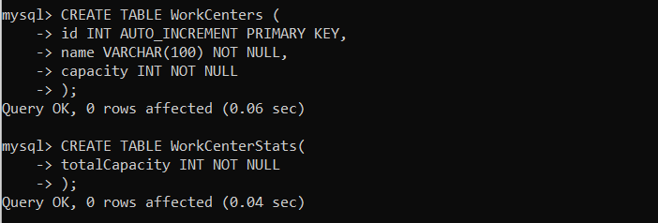

Next we create trigger and insert some values to check our trigger is working fine or not:

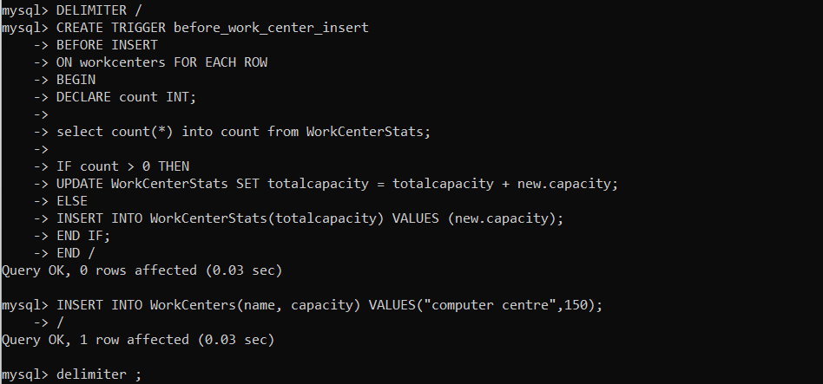

Now when we insert in work centers table automatically workcenterstats is updated:

For two insertion values:

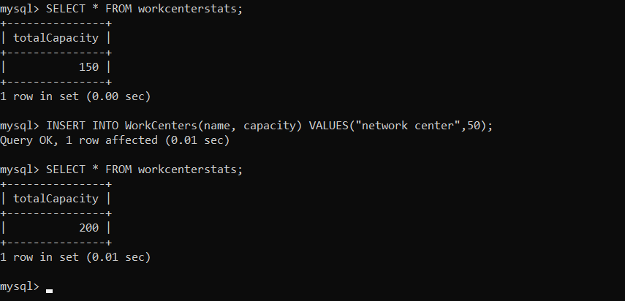

2. Write a trigger program to inserts a reminder into the reminders table if the birthdate

of the member is greater than 100 years.

First create the required tables for this question according to given tables:

The tables are:

1. Members.
2. Reminders.

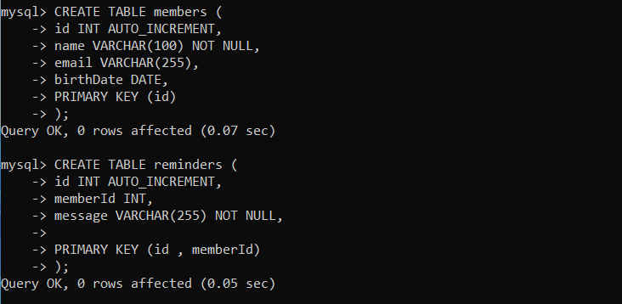

TRIGGER CREATED:

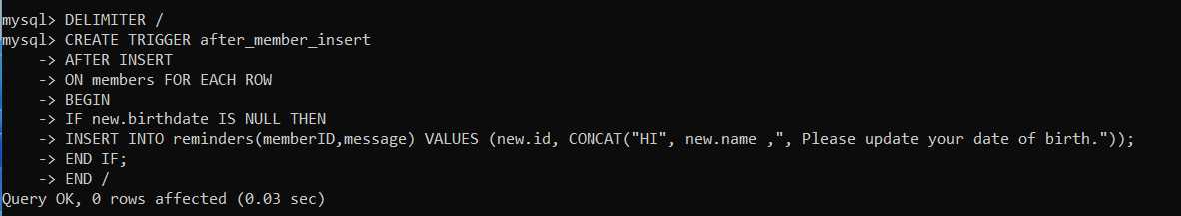

INSERTED TWO VALUES, ONE WITH NONE SO THE REMAIMDERS TABLE IS AUTOMATICALLY SHOWING MESSAGE:

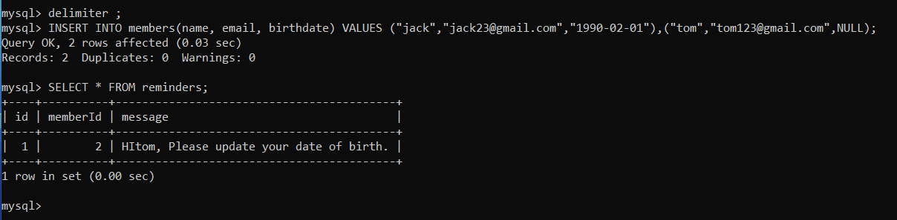

INSERTED ANOTHER VALUE WITH NONE SO THE REMAIMDERS TABLE IS AUTOMATICALLY SHOWING MESSAGE:

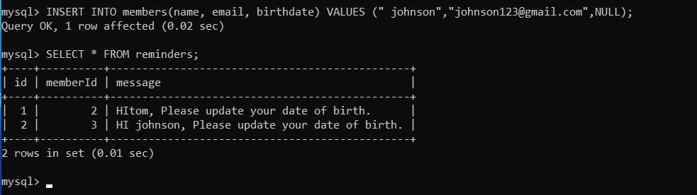

1. Create MySQL Trigger that inserts a new row into the SalaryArchives table before a

row from the Salaries table is deleted.

First create the required tables for this question according to given tables:

The tables are:

1. Salaries.
2. SalaryArchives and inserted values given in PDF.

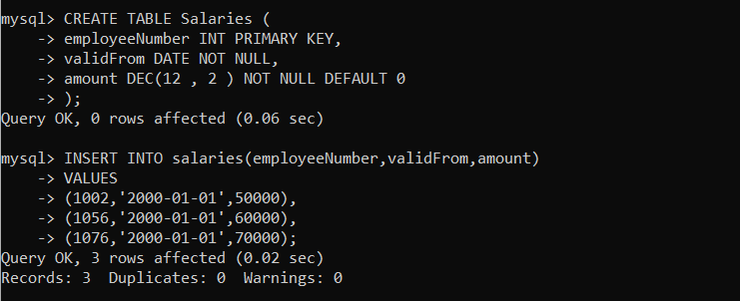

Table Salary archives created and values inserted:

And TRIGGER is created

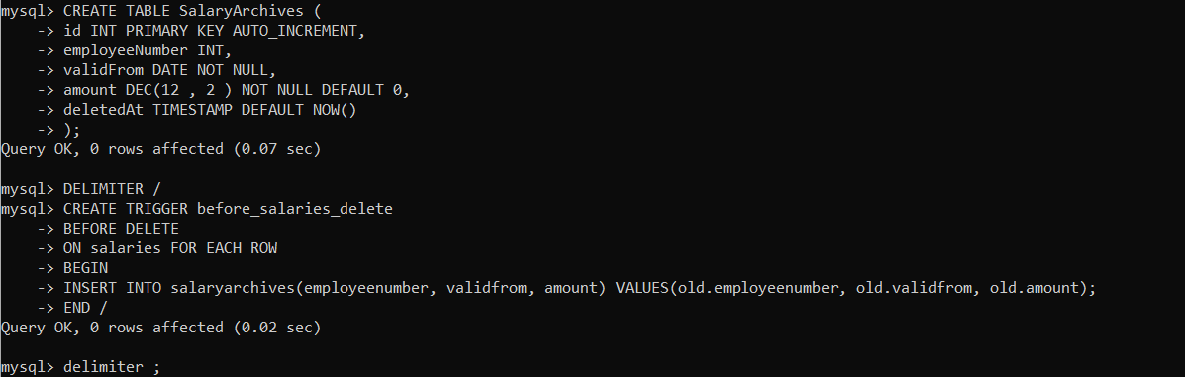

After deleting from salaries:

Automatically salaryarchives is getting updated.(we can see all details when it is getting deleted and etc …)

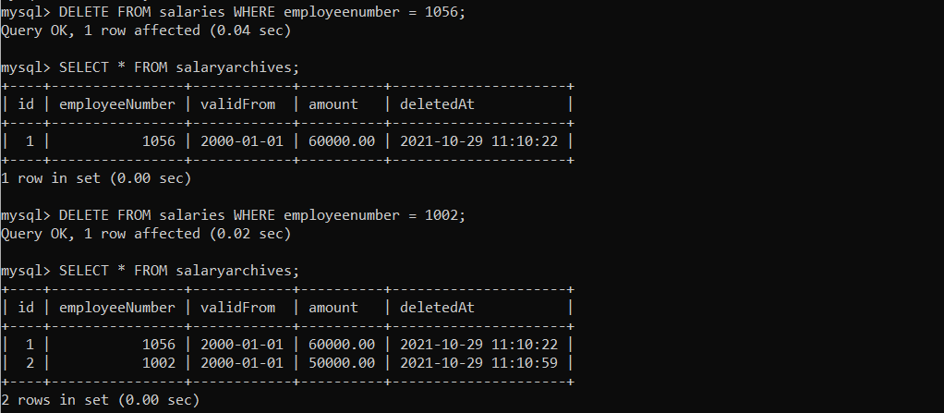

After deleting all the records from salaries:

Automatically Salary-archives updated.

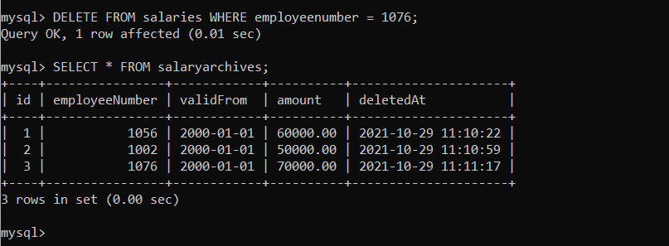

4. Create MySQL Trigger updates the total salary in the SalaryBudgets table after a row

is deleted from the Salaries table.

Dropping the existing table and creating for new triggers

Created and inserted values in the table

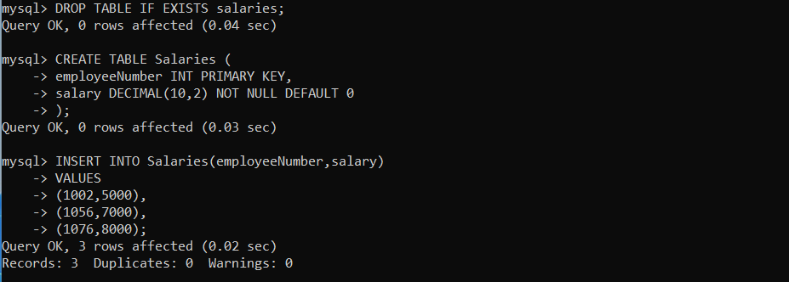

Creating salary budget table:

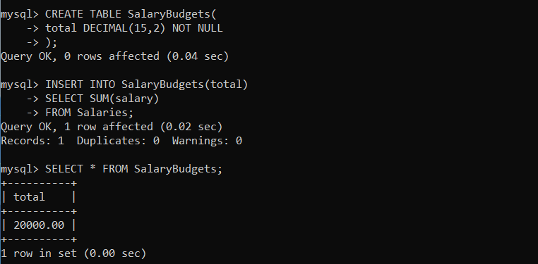

TRIGGER IS CREATED:

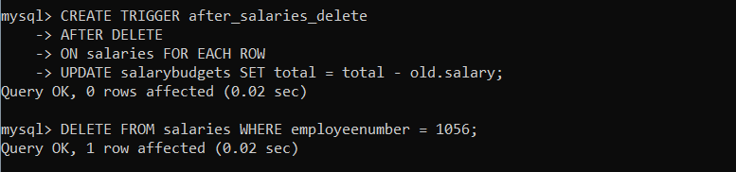

Some values are deleted and checking the total balance of the existing users

After deleting and checking total of remaining members :

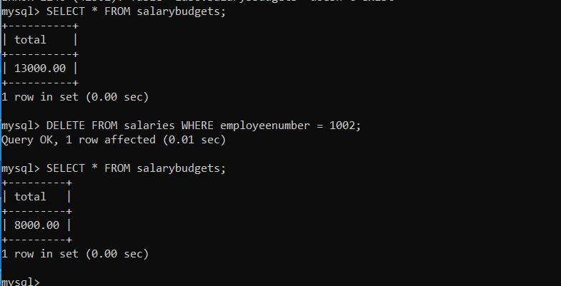

THANK YOU